Vlad Predovic

CS352 Usability Engineering

Due on Sunday April 3rd, 2016

Unit 1.2: HW #1: Design Principles

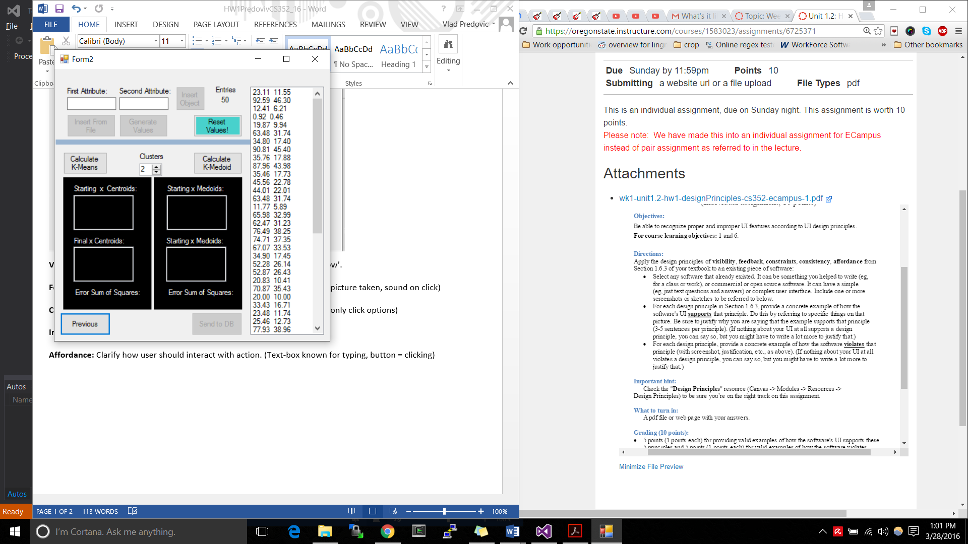

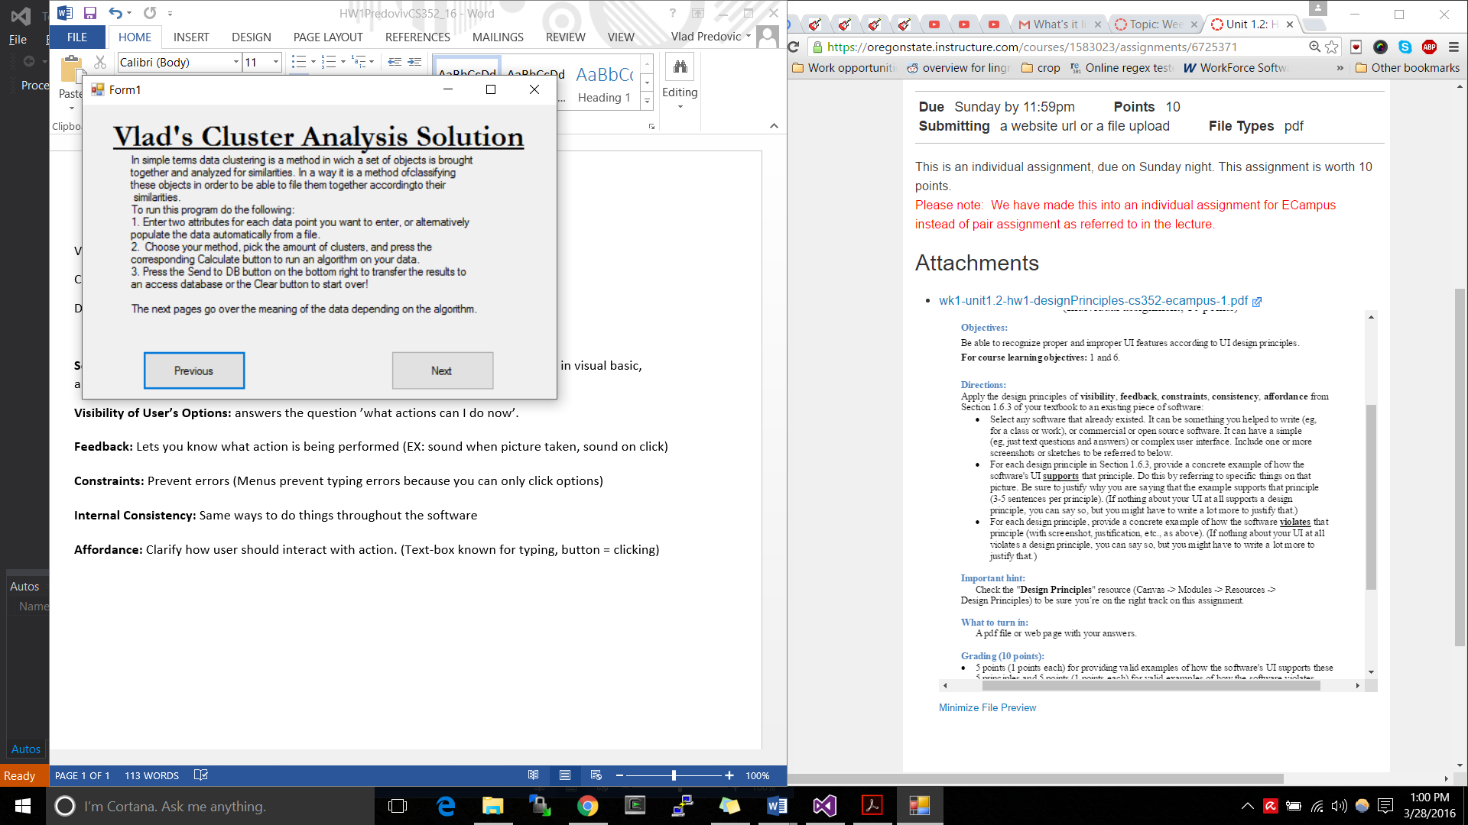**Software selected:** Term Project for a previous class IE 411. This program, developed in visual basic, allows a user to insert data and perform cluster analysis on it.

Figure 1

Figure 2

**Visibility of User’s Options:**

* The first few screens of the form application provide simple previous and next buttons with instructions on how to navigate. As far as the main screen observed in figure 2, visibility follows a top down approach. You insert your data at the top, select your test in the mid-section, and see your results at the bottom. This natural flow helps to improve visibility
* The application violates the principle of visibility with the button at the bottom left of figure two titled “Send to DB”. This button has multiple issues. It does not actually send the computed data to a database but a Microsoft access file. Additionally, the data has to be transferred to a unique file in the same containing folder. This information is not visible or in any way transmitting, and so the button is misleading.

**Feedback:**

* Within the main app form, when data is entered it automatically appears on the right side of the screen as shown in figure 2. This kind of feedback validates information for the user. Additionally, when a calculate button is pressed in the middle of figure 2,
* The application fails to provide any noise that verifies an action. All verification is visual. This violation could be improved by inserting sound bites when buttons are clicked.

**Constraints:**

* The app uses an intuitive system to avoid issues with data input. Depending on the text boxes filled or the values already added, a limited number of buttons will be enabled. As you can see from the picture above to the right, the user cannot insert an object because the first and second attribute fields are both blank.
* The Constraint design concept is violated when inputting large numbers into the data. The program does not check for numbers bigger than an integer that would lead to an overflow exception.

**Internal Consistency:**

* All back and next buttons are placed in the same position on every page to provide consistency. Buttons are for the most part aligned on the sides of the form to provide consistency. For the most part they are all also exactly the same size and shape.
* The Internal Consistency attribute is violated when displaying instructions on the first few forms. The instructions do not follow a consistent pattern which can lead to confusion. An example of one of these instruction forms is figure 1.

**Affordance:**

* For the most part the form application provides great affordance. For number inputs such as cluster selection (middle of figure 2), the user is provided with a number scroll bar. Buttons all have a uniform rectangular shape with a description of the application embedded into them. When hovering over a button, it lights up, inviting the user to click it as portrayed in figure 3.

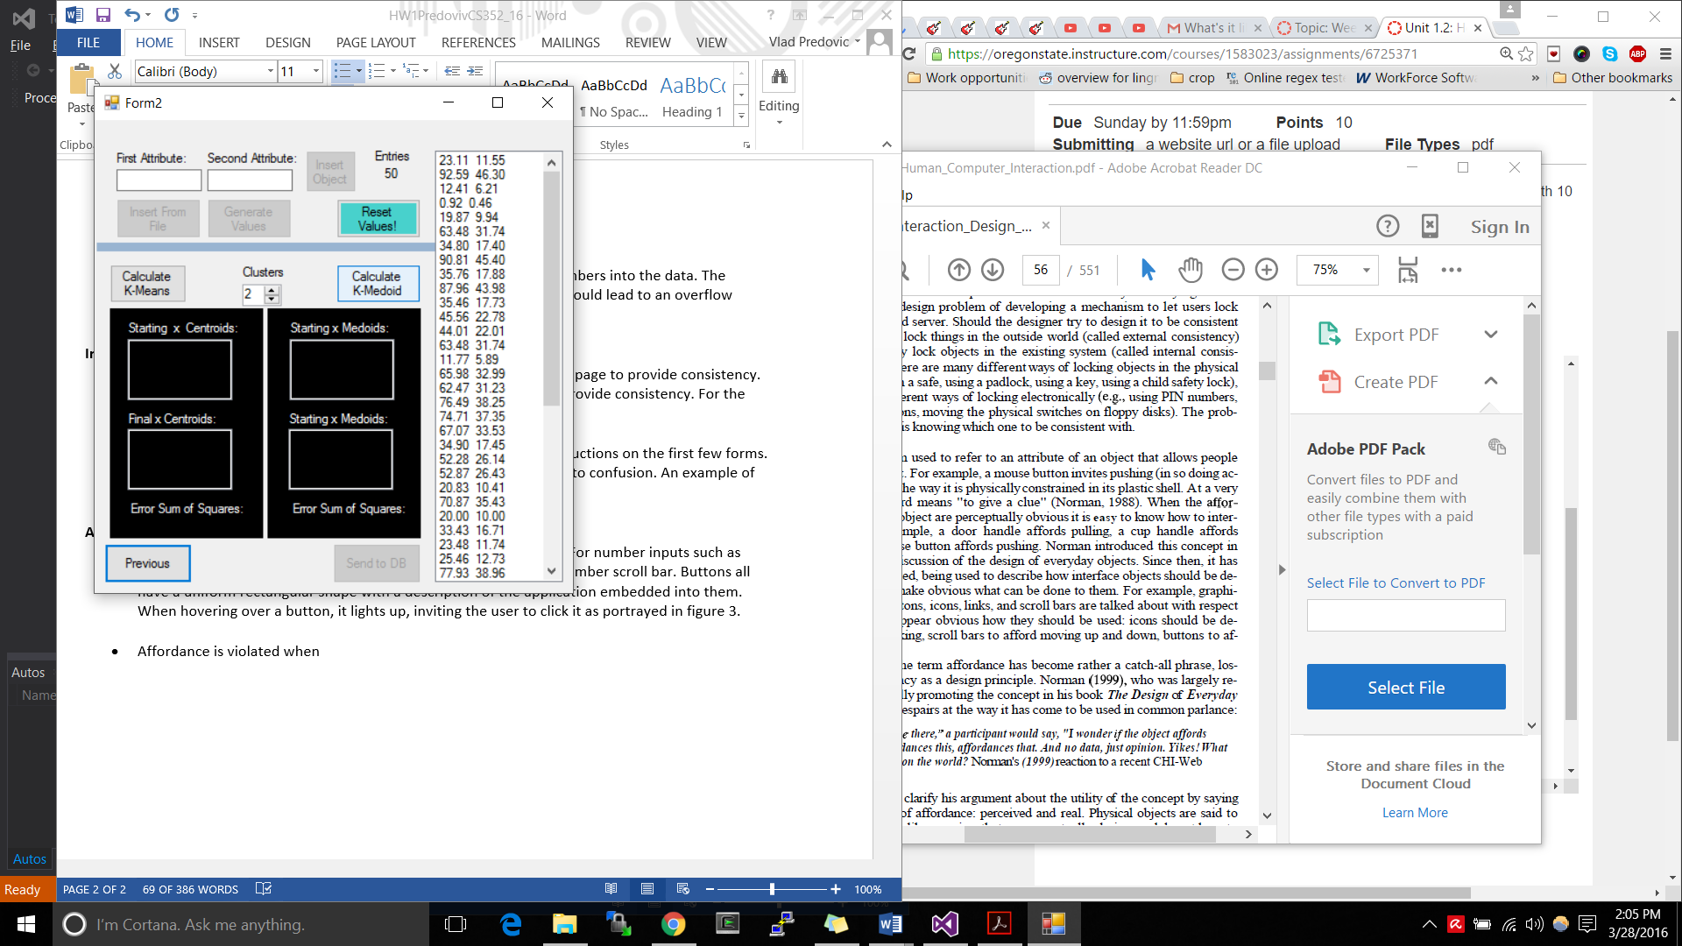

* Affordance is violated in a sense because the textbox to the right

Of the data in figure 3 gives the impression that you can add data

Directly. This however, is not true. You cannot alter the data.

Figure 3